# CIS 2104 EXERCISE 1-2: DDL and DML Part 1 of 2

INSTRUCTIONS:

1. Download the sample database from URL (<https://www.mysqltutorial.org/getting-started-with-mysql/mysql-sample-database>)
2. Analyze the following ERD and understand the database.

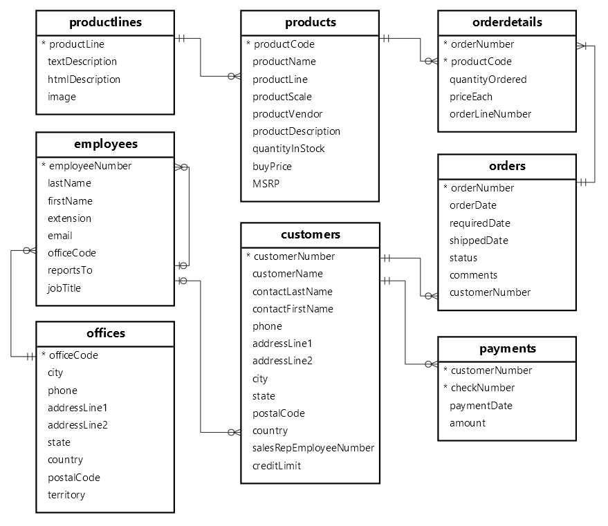

1. Extract the SQL dump file and check the content via NOTEPAD or VISUAL STUDIO. Study how DDL statements are made to create the database and its objects.
2. Import it to your local XAMPP File.
3. Answer the following questions in the SQL Querying Activity. The answer should contain the following:
   1. SQL QUERY
   2. RESULTING DATA (snippet for long results)
4. You may modify this paper to indicate your answers.
5. Once done, save the document as PDF before submitting via canvas.

**SQL QUERYING ACTIVITY**

1. Modify the table payments. Add a column status with default value of ‘paid’. Possible values are paid or unpaid only.

1. Assume that we are asked to reimagine the relationship between offices and employees. Employees are allowed to transfer to different offices, and we want to note these transfers. The new entity should record the original and destination department and effective date for such transfer. How would you define the new entity.
   1. Note: Do not modify existing relationship between offices and employee so as not to affect the current structure.

1. Find all products with a price under $100, sorted by product name in descending order (Z to A). A screen shot of a computer program

   Description automatically generated

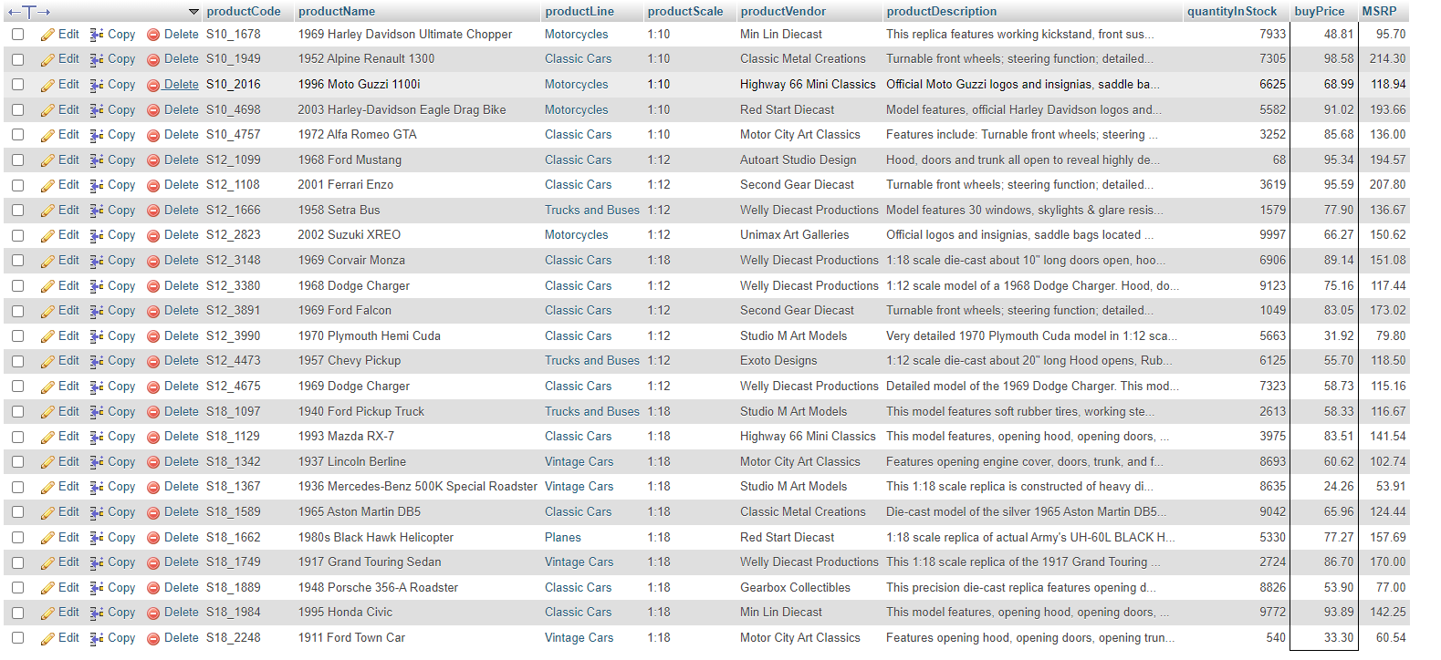

1. Calculate the total number of products with a product scale of 1:12

1. List all product names containing the word "airplane" (case-insensitive)

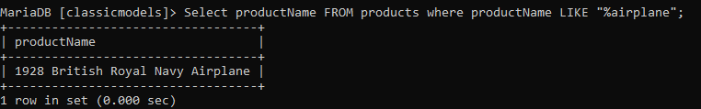

1. Find the 5 products with the highest quantity in stockA black screen with white text

   Description automatically generated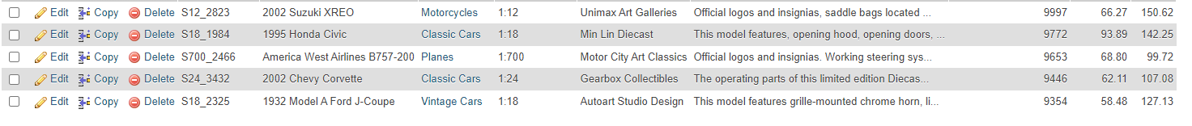
2. Aggregates: Find the average buy price for all productsA screen shot of a computer

   Description automatically generated
3. List all product lines with at least 10 products, sorted by the number of products in descending orderA black screen with white text

   Description automatically generated
4. Find all products with a price difference (MSRP - buyPrice) greater than 10% of their MSRP 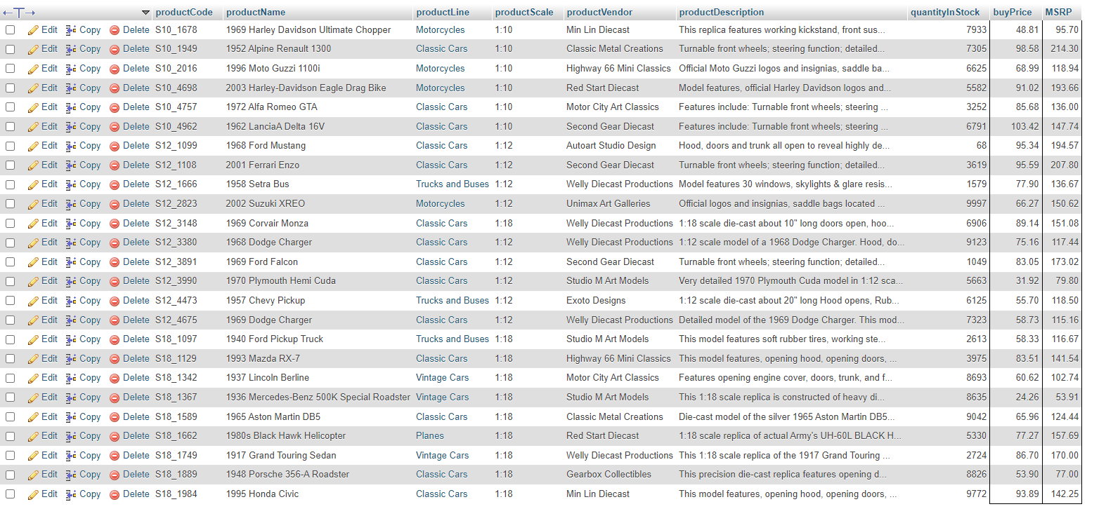
5. Calculate the total value of all products in stock for the "Classic Cars" product line A black screen with white text

   Description automatically generated
6. Find the top 3 product vendors with the most products in stock A black screen with white text

   Description automatically generated
7. List all products with a product name length greater than 20 characters 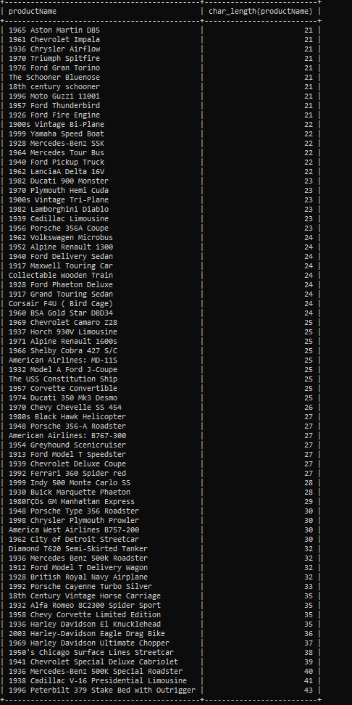
8. Find the average buy price for products with a product scale larger than 1:10 and a quantity in stock greater than 5 A black screen with white text

   Description automatically generated